SIMATS ENGINEERING

ASSESSMENT TOOL 3

COURSE NAME: COMPUTER NETWORKS COURSE CODE: CSA0706

COURSE OUTCOME COVERED

CO4:
Design network topologies star, mesh, bus, and hybrid using networking devices, transmission media, and cabling standards
(BL2,BL6)

Assessment Tool Weightage: 30%

QUESTIONS: 5 Total Marks:25
Annexure A

Comparative Analysis

Code of Conduct:
I RUCHITA.S (192572081) certify that this submission is my original work and that I have adhered to the guidelines specified for this assessment.
I understand that any violation of academic integrity rules will result in disciplinary action.

Signature of the student:

RUCHITA.S
Annexure A

Comparative Analysis
- Star topology is generally more expensive than bus topology because it requires a central device such as a switch or hub and more cabling to connect each node individually. In contrast, bus topology uses a single backbone cable, making it low-cost and easier to install. However, in terms of reliability, star topology is superior because failure of one node does not affect others, whereas a failure in the main bus cable can bring down the entire network. Performance is also better in star topology since data transmission is managed through a central device, reducing collisions, while bus topology suffers from performance degradation as more devices are added due to increased data traffic on the shared medium.
SOLUTION:

Star Topology vs Bus Topology

Comparison

Criteria | Star Topology | Bus Topology
Cost | More expensive because a central switch/hub and individual cables are required | Low cost because a single backbone cable is used
Installation | Requires more cabling | Simple and easy to install
Reliability | High; failure of one node does not affect others | Lower; failure of backbone can affect the entire network
Performance | Better performance because transmission is managed through the central device | Performance decreases as more devices are added
Collisions | Fewer collisions | More collisions due to shared medium
Troubleshooting | Easy to identify faulty node/cable | Backbone faults can be difficult to locate
Scalability | Can be expanded by adding ports/switches | Limited scalability
The assessment specifically states that star costs more but provides better reliability and performance, while bus is cheaper but becomes less efficient as traffic increases.
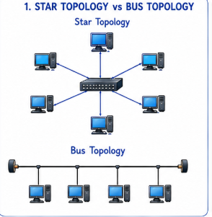

Conclusion
Star topology is preferred when reliability and performance are more important, whereas bus topology is suitable for small networks where low cost is the main consideration.

- Mesh topology offers very high fault tolerance because every node is connected to multiple other nodes, providing multiple paths for data transmission. If one link fails, data can still be routed through alternate paths without disrupting communication. In contrast, star topology has moderate fault tolerance; while failure of individual nodes does not affect the network, failure of the central hub or switch can cause the entire network to stop functioning. Therefore, mesh topology is more robust and reliable in critical environments compared to star topology.

SOLUTION:

Comparison

Criteria | Mesh Topology | Star Topology
Fault tolerance | Very high | Moderate
Connections | Multiple connections between nodes | All nodes connect to central switch
Alternative paths | Available | Generally unavailable if central switch fails
Single point of failure | Very low | Central switch is a single point of failure
Reliability | Very high | Moderate to high
Cost | High | Lower than mesh
Best suited for | Critical networks | Normal enterprise/office networks
The assessment explains that mesh provides multiple paths, so communication can continue when a link fails. In star topology, failure of the central switch can stop the entire network.
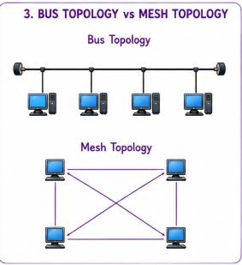

Example
If one link in a mesh fails:
PC1 ---- PC2
\ /
\ /
PC3
Data can use another path.
In a star network:
PC1 \
PC2 -- SWITCH -- PC3
PC4 /
If the switch fails, all connected devices lose network connectivity.

Conclusion
Mesh topology provides better fault tolerance and reliability than star topology, making it suitable for critical environments where network availability is essential.
- Bus topology is simple and easy to install because it uses a single backbone cable with minimal connections, making it suitable for small networks. On the other hand, mesh topology is highly complex to install as each node must be connected to every other node, requiring a large number of cables and ports. This complexity increases significantly as the number of devices grows, making mesh topology time-consuming and costly to implement compared to the straightforward setup of bus topology.

SOLUTION:

Comparison

Criteria | Bus Topology | Mesh Topology
Installation | Simple | Complex
Cabling | One main backbone cable | Many connections
Number of ports | Low | High
Cost | Low | High
Maintenance | Relatively simple | Difficult
Scalability | Limited | Complex as devices increase
Installation time | Less | More
Best suited for | Small networks | Highly reliable networks
The assessment describes bus as simple because it uses a single backbone, while mesh requires many connections between devices and becomes increasingly complex as the number of devices grows.
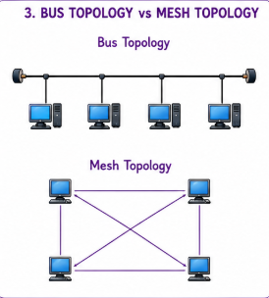

Complexity
For n devices, a full mesh requires:
2n(n−1)​
links.
For example, with 4 devices:
24(4−1)​=212​=6 links
Therefore, the number of connections increases rapidly as more devices are added.

Conclusion
Bus topology is much easier and cheaper to install, while mesh topology is complex and expensive but provides excellent reliability
- Hybrid topology is highly scalable because it combines two or more different topologies (such as star, mesh, or bus), allowing the network to expand flexibly according to organizational needs. New segments can be added without affecting the existing network structure. In comparison, star topology is also scalable but to a limited extent, as it depends on the capacity of the central device (switch or hub). Once the central device reaches its port limit, expansion requires additional hardware. Thus, hybrid topology provides greater scalability than star topology.

SOLUTION:

Comparison

Criteria | Hybrid Topology | Star Topology
Scalability | Very high | Moderate to high
Network expansion | New segments can be added easily | Limited by switch ports
Flexibility | Very high | Moderate
Topology combinations | Can combine star, mesh, bus, etc. | Uses star structure
Large networks | Highly suitable | Suitable with additional switches
Expansion cost | Depends on design | Additional hardware may be required
Best suited for | Large organizations/campuses | Small and medium networks
The assessment states that hybrid topology can combine different topologies and allow new segments to be added without disturbing the existing structure. Star topology is scalable only up to the capacity of its central device.
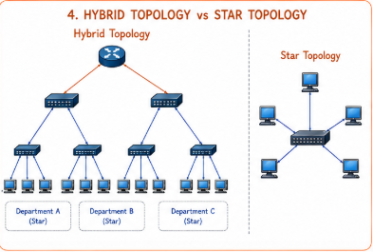

Example
A university can use:
CAMPUS CORE
/ \
MESH MESH
/ \
Building A Building B
STAR STAR
/ | \ / | \
PCs PCs PCs PCs PCs PCs

Conclusion
Hybrid topology provides greater scalability and flexibility than star topology, especially for large organizations such as universities and enterprises.

- In terms of maintenance, star topology is relatively easy to manage because issues can be quickly identified and isolated to a specific node or cable. Mesh topology, while highly reliable, is difficult to maintain due to its complex structure and large number of connections, making troubleshooting time-consuming. Bus topology is harder to maintain than star because faults in the backbone cable can disrupt the entire network and are difficult to locate. Hybrid topology has moderate maintenance complexity; while it benefits from flexibility, managing multiple combined topologies requires careful monitoring and skilled administration.

SOLUTION:

Comparison Table
Criteria | Star | Mesh | Bus | Hybrid
Maintenance | Easy | Difficult | Difficult | Moderate
Troubleshooting | Easy | Complex | Difficult | Moderate
Fault identification | Easy | Can be complex | Backbone fault is difficult to locate | Depends on topology used
Cabling complexity | Moderate | Very high | Low | High/variable
Administration | Simple | Requires skilled administration | Relatively simple but fault diagnosis is difficult | Requires careful management
Reliability | High | Very high | Low | High
Best feature | Easy maintenance | High reliability | Low cost | Flexibility
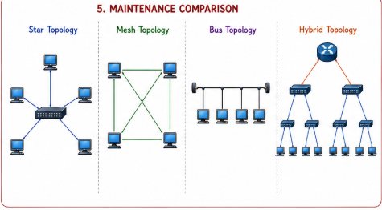

Conclusion
For maintenance, star topology is the easiest, while mesh is the most complex. Bus is simple in structure but difficult when the backbone develops a fault. Hybrid topology provides flexibility but requires skilled administration because multiple topology types are combined.

RUBRICS FOR CALCULATION

Criteria | Weightage | Exemplary (4) | Proficient (3) | Developing (2) | Beginning (1)
Understanding of Concepts | 15% | Demonstrates  complete and in-depth understanding of all concepts being compared | Good understanding with minor  gaps | Basic understanding; some concepts unclear | Poor understanding of concepts
Comparison Depth | 20% | Provides detailed, insightful, and meaningful  comparisons  across multiple aspects | Adequate comparison with relevant points | Limited comparison; lacks depth | Minimal or incorrect comparison
Criteria Selection | 10% | Selects highly relevant and  appropriate comparison parameters | Mostly relevant criteria | Some irrelevant or missing  criteria | Poor or no criteria selection
Analytical Skills | 15% | Strong analysis with logical reasoning and clear justification | Good analysis with some justification | Basic analysis with weak reasoning | No clear analysis
Organization & Structure | 10% | Well-organized, clear, and logically structured | Generally organized | Somewhat disorganized | Poorly structured
Use of  Examples / Evidence | 10% | Uses strong, relevant  examples or data to support comparison | Uses some examples | Limited examples | No supporting examples
Clarity of Presentation | 10% | Very clear, concise, and easy to understand | Mostly clear | Somewhat unclear | Difficult to understand
Conclusion & Insights | 10% | Insightful conclusion with strong justification | Clear conclusion | Basic conclusion | No or weak conclusion

